**Project Initialization and Planning Phase**

| Date | 14 July 2024 |
| --- | --- |
| Team ID | 739949 |
| Project Name | Blood Donation Prediction |
| Maximum Marks | 3 Marks |

**Define Problem Statements (Customer Problem Statement Template):**

Blood donation is a crucial aspect of healthcare systems worldwide, ensuring the availability of blood for transfusions, surgeries, and other medical procedures. However, maintaining a steady and sufficient supply of blood is a constant challenge for blood banks and hospitals. To address this issue, it is essential to predict potential donors who are likely to donate blood in the future, enabling better planning and outreach strategie.

**Example:**

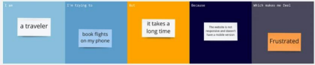

**Which makes me feel**

**Because**

**But**

**I am**

**I’m trying to**

Health

provider

Anxious about to meet patient

Fluctuations impact on treatment

Variability in donor participation

Predict blood supply levels

|  |  |  |  |  |  |
| --- | --- | --- | --- | --- | --- |
| **Problem**  **Statement (PS)** | **I am**  **(Customer)** | **I’m trying to** | **But** | **Because** | **Which makes me feel** |
| PS | Healthcare providers | Predict blood supply levels | The variability  in donor participation  Makes it challenging | Fluctuations in donation  Can directly impact medical treatments | Anxious about our capacity to meet patient needs |